МИНИСТЕРСТВО НАУКИ И ВЫСШЕГО ОБРАЗОВАНИЯ   
РОССИЙСКОЙ ФЕДЕРАЦИИ

ФЕДЕРАЛЬНОЕ ГОСУДАРСТВЕННОЕ БЮДЖЕТНОЕ ОБРАЗОВАТЕЛЬНОЕ УЧРЕЖДЕНИЕ ВЫСШЕГО ОБРАЗОВАНИЯ

**«БЕЛГОРОДСКИЙ ГОСУДАРСТВЕННЫЙ**

**ТЕХНОЛОГИЧЕСКИЙ УНИВЕРСИТЕТ им. В. Г. ШУХОВА»**

**(БГТУ им. В.Г. Шухова)**

Кафедра программного обеспечения вычислительной техники и автоматизированных систем

Лабораторная работа №3.1

по дисциплине «Программирование микроконтроллеров»

тема: «Программирование отображения графиков с помощью ЦАП на микроконтроллере MC8051»

Выполнил: ст. группы ВТ-32

Воскобойников И. С.

Проверил: Гольцов Ю. А.

Белгород 2021 г.

**Цель работы**: изучить принципы работы ЦАП в микроконтроллерах серии MCS-51.

**Задание к работе**:

Создать программу для вывода графиков на ЦАП.

Таблица соответствия нажатой клавиши и графика

|  |  |
| --- | --- |
| Нажатая клавиша | График |
| 1 | Синусоида |
| 2 | Пила |
| 3 | Треугольник |
| 4 | Парабола |
| 5 | Кубическая парабола |
| 6 | Клыки |

**Соответствие графиков и наборов данных для вывода**

**Синусоида**

db 127, 118, 109, 99, 90, 81, 73, 64, 56, 48, 41, 35, 28, 23, 17, 13, 9, 6, 3, 1, 0, 0, 0, 1, 2, 4, 7, 11, 15, 20, 25, 31, 38, 45, 52, 60, 68, 77, 86, 95, 104, 113, 123, 132, 142, 151, 160, 169, 178, 187, 195, 203, 210, 217, 224, 230, 235, 240, 244, 248, 251, 253, 254, 255, 255, 255, 254, 252, 249, 246, 242, 238, 232, 227, 220, 214, 207, 199, 191, 182, 174, 165, 156, 146, 137, 127, 118, 109, 99, 90, 81, 73, 64, 56, 48, 41, 35, 28, 23, 17, 13, 9, 6, 3, 1, 0, 0, 0, 1, 2, 4, 7, 11, 15, 20, 25, 31, 38, 45, 52, 60, 68, 77, 86, 95, 104, 113, 123, 132, 142, 151, 160, 169, 178, 187, 195, 203, 210, 217, 224, 230, 235, 240, 244, 248, 251, 253, 254, 255, 255, 255, 254, 252, 249, 246, 242, 238, 232, 227, 220, 214, 207, 199, 191, 182, 174, 165, 156, 146, 137, 128, 118, 109, 99, 90, 81, 73, 64, 56, 48, 41, 35, 28, 23, 17, 13, 9, 6, 3, 1, 0, 0, 0, 1, 2, 4, 7, 11, 15, 20, 25, 31, 38, 45, 52, 60, 68, 77, 86, 95, 104, 113, 123, 132, 142, 151, 160, 169, 178, 187, 195, 203, 210, 217, 224, 230, 235, 240, 244, 248, 251, 253, 254, 255, 255, 255, 254, 252, 249, 246, 242, 238, 232, 227, 220, 214, 207, 199, 191, 182, 174, 165, 156, 146, 137, 128

**Пила**

db 0, 6, 12, 18, 24, 31, 37, 43, 49, 55, 62, 68, 74, 80, 87, 93, 99, 105, 111, 118, 124, 130, 136, 143, 149, 155, 161, 167, 174, 180, 186, 192, 199, 205, 211, 217, 223, 230, 236, 242, 248, 255, 0, 6, 12, 18, 24, 31, 37, 43, 49, 55, 62, 68, 74, 80, 87, 93, 99, 105, 111, 118, 124, 130, 136, 143, 149, 155, 161, 167, 174, 180, 186, 192, 199, 205, 211, 217, 223, 230, 236, 242, 248, 255, 0, 6, 12, 18, 24, 31, 37, 43, 49, 55, 62, 68, 74, 80, 87, 93, 99, 105, 111, 118, 124, 130, 136, 143, 149, 155, 161, 167, 174, 180, 186, 192, 199, 205, 211, 217, 223, 230, 236, 242, 248, 255, 0, 6, 12, 18, 24, 31, 37, 43, 49, 55, 62, 68, 74, 80, 87, 93, 99, 105, 111, 118, 124, 130, 136, 143, 149, 155, 161, 167, 174, 180, 186, 192, 199, 205, 211, 217, 223, 230, 236, 242, 248, 255, 0, 6, 12, 18, 24, 31, 37, 43, 49, 55, 62, 68, 74, 80, 87, 93, 99, 105, 111, 118, 124, 130, 136, 143, 149, 155, 161, 167, 174, 180, 186, 192, 199, 205, 211, 217, 223, 230, 236, 242, 248, 255, 0, 6, 12, 18, 24, 31, 37, 43, 49, 55, 62, 68, 74, 80, 87, 93, 99, 105, 111, 118, 124, 130, 136, 143, 149, 155, 161, 167, 174, 180, 186, 192, 199, 205, 211, 217, 223, 230, 236, 242, 248, 255

**Треугольник**

db 0, 6, 12, 18, 24, 31, 37, 43, 49, 55, 62, 68, 74, 80, 87, 93, 99, 105, 111, 118, 124, 130, 136, 143, 149, 155, 161, 167, 174, 180, 186, 192, 199, 205, 211, 217, 223, 230, 236, 242, 248, 255, 255, 248, 242, 236, 230, 223, 217, 211, 205, 199, 192, 186, 180, 174, 167, 161, 155, 149, 143, 136, 130, 124, 118, 111, 105, 99, 93, 87, 80, 74, 68, 62, 55, 49, 43, 37, 31, 24, 18, 12, 6, 0, 0, 6, 12, 18, 24, 31, 37, 43, 49, 55, 62, 68, 74, 80, 87, 93, 99, 105, 111, 118, 124, 130, 136, 143, 149, 155, 161, 167, 174, 180, 186, 192, 199, 205, 211, 217, 223, 230, 236, 242, 248, 255, 255, 248, 242, 236, 230, 223, 217, 211, 205, 199, 192, 186, 180, 174, 167, 161, 155, 149, 143, 136, 130, 124, 118, 111, 105, 99, 93, 87, 80, 74, 68, 62, 55, 49, 43, 37, 31, 24, 18, 12, 6, 0, 0, 6, 12, 18, 24, 31, 37, 43, 49, 55, 62, 68, 74, 80, 87, 93, 99, 105, 111, 118, 124, 130, 136, 143, 149, 155, 161, 167, 174, 180, 186, 192, 199, 205, 211, 217, 223, 230, 236, 242, 248, 255, 255, 248, 242, 236, 230, 223, 217, 211, 205, 199, 192, 186, 180, 174, 167, 161, 155, 149, 143, 136, 130, 124, 118, 111, 105, 99, 93, 87, 80, 74, 68, 62, 55, 49, 43, 37, 31, 24, 18, 12, 6, 0

**Парабола**

db 255, 232, 209, 188, 167, 148, 130, 113, 98, 83, 70, 58, 47, 37, 28, 20, 14, 9, 5, 2, 0, 0, 0, 2, 5, 9, 14, 20, 28, 37, 47, 58, 70, 83, 98, 113, 130, 148, 167, 188, 209, 232, 255, 255, 232, 209, 188, 167, 148, 130, 113, 98, 83, 70, 58, 47, 37, 28, 20, 14, 9, 5, 2, 0, 0, 0, 2, 5, 9, 14, 20, 28, 37, 47, 58, 70, 83, 98, 113, 130, 148, 167, 188, 209, 232, 255, 255, 232, 209, 188, 167, 148, 130, 113, 98, 83, 70, 58, 47, 37, 28, 20, 14, 9, 5, 2, 0, 0, 0, 2, 5, 9, 14, 20, 28, 37, 47, 58, 70, 83, 98, 113, 130, 148, 167, 188, 209, 232, 255, 255, 232, 209, 188, 167, 148, 130, 113, 98, 83, 70, 58, 47, 37, 28, 20, 14, 9, 5, 2, 0, 0, 0, 2, 5, 9, 14, 20, 28, 37, 47, 58, 70, 83, 98, 113, 130, 148, 167, 188, 209, 232, 255, 255, 232, 209, 188, 167, 148, 130, 113, 98, 83, 70, 58, 47, 37, 28, 20, 14, 9, 5, 2, 0, 0, 0, 2, 5, 9, 14, 20, 28, 37, 47, 58, 70, 83, 98, 113, 130, 148, 167, 188, 209, 232, 255, 255, 232, 209, 188, 167, 148, 130, 113, 98, 83, 70, 58, 47, 37, 28, 20, 14, 9, 5, 2, 0, 0, 0, 2, 5, 9, 14, 20, 28, 37, 47, 58, 70, 83, 98, 113, 130, 148, 167, 188, 209

**Кубическая парабола**

db 0, 17, 33, 47, 59, 71, 81, 89, 97, 103, 109, 113, 117, 120, 122, 124, 125, 126, 127, 127, 127, 127, 127, 127, 127, 128, 129, 130, 132, 134, 137, 141, 145, 151, 157, 165, 173, 183, 195, 207, 221, 237, 255, 0, 17, 33, 47, 59, 71, 81, 89, 97, 103, 109, 113, 117, 120, 122, 124, 125, 126, 127, 127, 127, 127, 127, 127, 127, 128, 129, 130, 132, 134, 137, 141, 145, 151, 157, 165, 173, 183, 195, 207, 221, 237, 255, 0, 17, 33, 47, 59, 71, 81, 89, 97, 103, 109, 113, 117, 120, 122, 124, 125, 126, 127, 127, 127, 127, 127, 127, 127, 128, 129, 130, 132, 134, 137, 141, 145, 151, 157, 165, 173, 183, 195, 207, 221, 237, 255, 0, 17, 33, 47, 59, 71, 81, 89, 97, 103, 109, 113, 117, 120, 122, 124, 125, 126, 127, 127, 127, 127, 127, 127, 127, 128, 129, 130, 132, 134, 137, 141, 145, 151, 157, 165, 173, 183, 195, 207, 221, 237, 255, 0, 17, 33, 47, 59, 71, 81, 89, 97, 103, 109, 113, 117, 120, 122, 124, 125, 126, 127, 127, 127, 127, 127, 127, 127, 128, 129, 130, 132, 134, 137, 141, 145, 151, 157, 165, 173, 183, 195, 207, 221, 237, 255, 0, 17, 33, 47, 59, 71, 81, 89, 97, 103, 109, 113, 117, 120, 122, 124, 125, 126, 127, 127, 127, 127, 127, 127, 127, 128, 129, 130, 132, 134, 137, 141, 145, 151, 157, 165, 173, 183, 195, 207, 221, 237, 255

**Клыки**

db 255, 219, 185, 153, 123, 94, 67, 42, 19, 2, 22, 40, 57, 71, 85, 96, 105, 113, 119, 124, 126, 127, 126, 124, 119, 113, 105, 96, 85, 71, 57, 40, 22, 2, 19, 42, 67, 94, 123, 153, 185, 219, 255, 255, 219, 185, 153, 123, 94, 67, 42, 19, 2, 22, 40, 57, 71, 85, 96, 105, 113, 119, 124, 126, 127, 126, 124, 119, 113, 105, 96, 85, 71, 57, 40, 22, 2, 19, 42, 67, 94, 123, 153, 185, 219, 255, 255, 219, 185, 153, 123, 94, 67, 42, 19, 2, 22, 40, 57, 71, 85, 96, 105, 113, 119, 124, 126, 127, 126, 124, 119, 113, 105, 96, 85, 71, 57, 40, 22, 2, 19, 42, 67, 94, 123, 153, 185, 219, 255, 255, 219, 185, 153, 123, 94, 67, 42, 19, 2, 22, 40, 57, 71, 85, 96, 105, 113, 119, 124, 126, 127, 126, 124, 119, 113, 105, 96, 85, 71, 57, 40, 22, 2, 19, 42, 67, 94, 123, 153, 185, 219, 255, 255, 219, 185, 153, 123, 94, 67, 42, 19, 2, 22, 40, 57, 71, 85, 96, 105, 113, 119, 124, 126, 127, 126, 124, 119, 113, 105, 96, 85, 71, 57, 40, 22, 2, 19, 42, 67, 94, 123, 153, 185, 219, 255, 255, 219, 185, 153, 123, 94, 67, 42, 19, 2, 22, 40, 57, 71, 85, 96, 105, 113, 119, 124, 126, 127, 126, 124, 119, 113, 105, 96, 85, 71, 57, 40, 22, 2, 19, 42, 67, 94, 123, 153, 185, 219, 255

**Блок схемы разработанных подпрограмм**

main

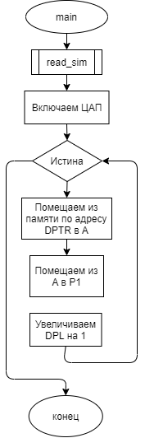

read_sim

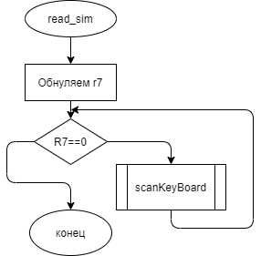

scanKeyBoard

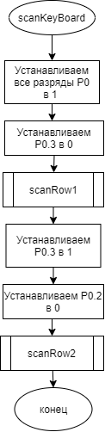

scanRow1

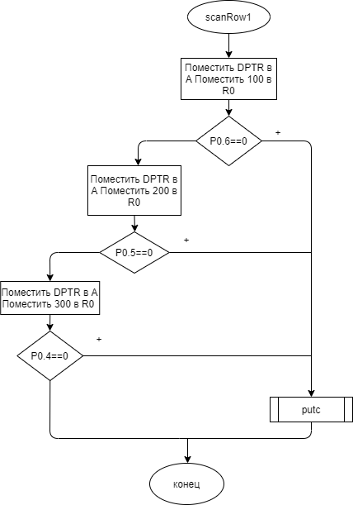

scanRow2

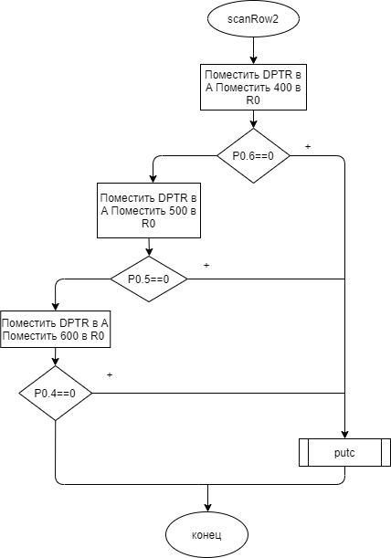

putc

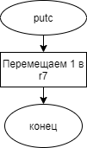

**Пример выполнения работы**

**Синусоида**

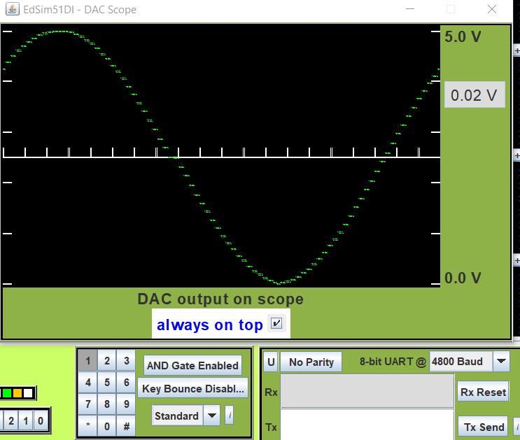

**Пила**

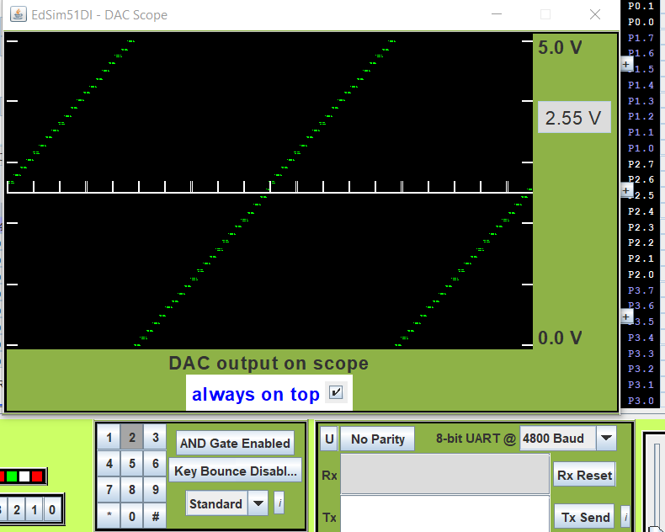

**Треугольник**

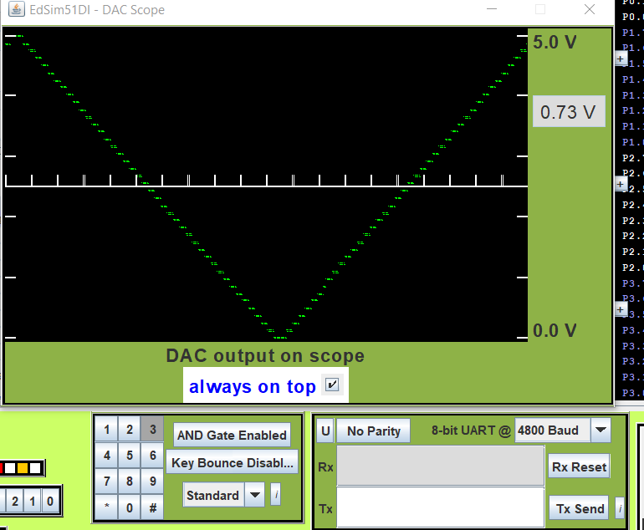

**Парабола**

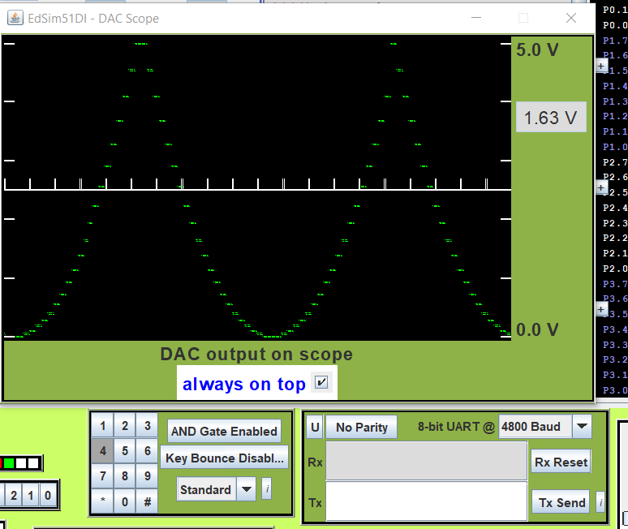

**Кубическая парабола**

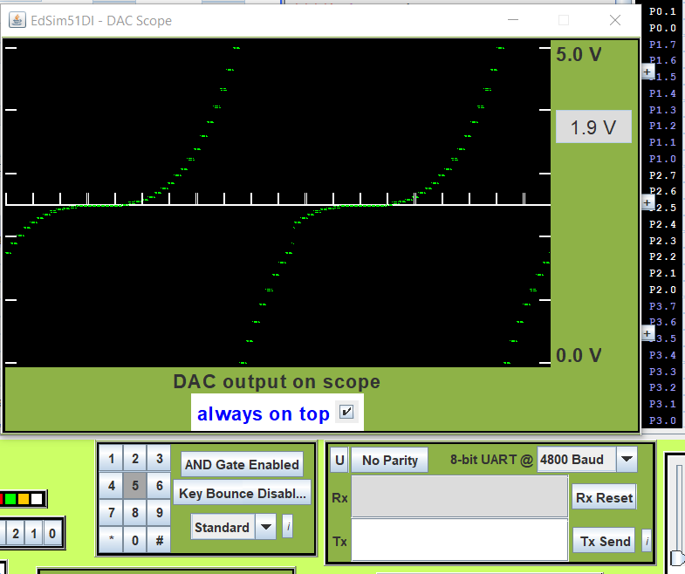

**Клыки**

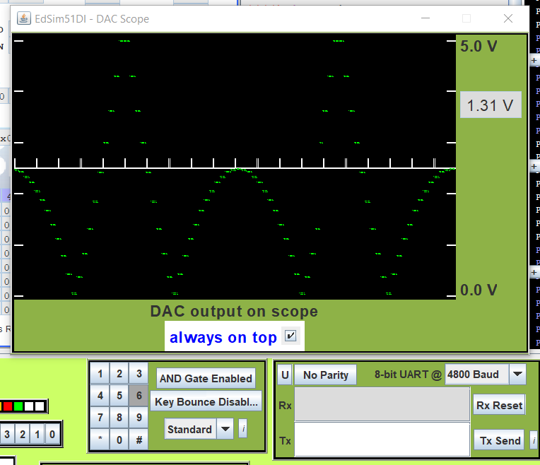

**lab_3.1.asm**

org 0h

jmp main

org 30h

main:

; Вводим DPTR

call read_sim

; Включаем ЦАП

clr P0.7

main_loop:

; Вывод на ЦАП величины из таблицы

mov A, #0

movc A, @A+DPTR

mov P1, A

; Увеличиваем только младшие 8 бит регистра DPTR

;после переполнения оно идет на следующий круг

inc DPL

jmp main_loop

read_sim:

mov r7, #0

read_loop:

;пока не считываем число в не выходим из цикла

cjne r7, #0, read_out

call scanKeyBoard

jmp read_loop

read_out:

ret

; Сканирование по рядам

scanKeyBoard:

mov p0, #11111111b

clr p0.3

CALL scanRow1

cjne r7, #0, scan_out

setb p0.3

clr p0.2

CALL scanRow2

scan_out:

ret

; Сканирование первого ряда

scanRow1:

MOV DPTR, #0100h

JNB P0.6, pressKeyR1

MOV DPTR, #0200h

JNB P0.5, pressKeyR1

MOV DPTR, #0300h

JNB P0.4, pressKeyR1

ret ; ключ не найден

pressKeyR1:

call putc

ret

; Сканирование второго ряда

scanRow2:

MOV DPTR, #0400h

JNB P0.6, pressKeyR1

MOV DPTR, #0500h

JNB P0.5, pressKeyR1

MOV DPTR, #0600h

JNB P0.4, pressKeyR1

ret ; ключ не найден

pressKeyR2:

call putc

ret

;перевеод числа из A в r7

putc:

mov r7, #1

ret

org 0100h

; Синусоида

db 127, 118, 109, 99, 90, 81, 73, 64, 56, 48, 41, 35, 28, 23, 17, 13, 9, 6, 3, 1, 0, 0, 0, 1, 2, 4, 7, 11, 15, 20, 25, 31, 38, 45, 52, 60, 68, 77, 86, 95, 104, 113, 123, 132, 142, 151, 160, 169, 178, 187, 195, 203, 210, 217, 224, 230, 235, 240, 244, 248, 251, 253, 254, 255, 255, 255, 254, 252, 249, 246, 242, 238, 232, 227, 220, 214, 207, 199, 191, 182, 174, 165, 156, 146, 137, 127, 118, 109, 99, 90, 81, 73, 64, 56, 48, 41, 35, 28, 23, 17, 13, 9, 6, 3, 1, 0, 0, 0, 1, 2, 4, 7, 11, 15, 20, 25, 31, 38, 45, 52, 60, 68, 77, 86, 95, 104, 113, 123, 132, 142, 151, 160, 169, 178, 187, 195, 203, 210, 217, 224, 230, 235, 240, 244, 248, 251, 253, 254, 255, 255, 255, 254, 252, 249, 246, 242, 238, 232, 227, 220, 214, 207, 199, 191, 182, 174, 165, 156, 146, 137, 128, 118, 109, 99, 90, 81, 73, 64, 56, 48, 41, 35, 28, 23, 17, 13, 9, 6, 3, 1, 0, 0, 0, 1, 2, 4, 7, 11, 15, 20, 25, 31, 38, 45, 52, 60, 68, 77, 86, 95, 104, 113, 123, 132, 142, 151, 160, 169, 178, 187, 195, 203, 210, 217, 224, 230, 235, 240, 244, 248, 251, 253, 254, 255, 255, 255, 254, 252, 249, 246, 242, 238, 232, 227, 220, 214, 207, 199, 191, 182, 174, 165, 156, 146, 137, 128

org 0200h

; Пила

db 0, 6, 12, 18, 24, 31, 37, 43, 49, 55, 62, 68, 74, 80, 87, 93, 99, 105, 111, 118, 124, 130, 136, 143, 149, 155, 161, 167, 174, 180, 186, 192, 199, 205, 211, 217, 223, 230, 236, 242, 248, 255, 0, 6, 12, 18, 24, 31, 37, 43, 49, 55, 62, 68, 74, 80, 87, 93, 99, 105, 111, 118, 124, 130, 136, 143, 149, 155, 161, 167, 174, 180, 186, 192, 199, 205, 211, 217, 223, 230, 236, 242, 248, 255, 0, 6, 12, 18, 24, 31, 37, 43, 49, 55, 62, 68, 74, 80, 87, 93, 99, 105, 111, 118, 124, 130, 136, 143, 149, 155, 161, 167, 174, 180, 186, 192, 199, 205, 211, 217, 223, 230, 236, 242, 248, 255, 0, 6, 12, 18, 24, 31, 37, 43, 49, 55, 62, 68, 74, 80, 87, 93, 99, 105, 111, 118, 124, 130, 136, 143, 149, 155, 161, 167, 174, 180, 186, 192, 199, 205, 211, 217, 223, 230, 236, 242, 248, 255, 0, 6, 12, 18, 24, 31, 37, 43, 49, 55, 62, 68, 74, 80, 87, 93, 99, 105, 111, 118, 124, 130, 136, 143, 149, 155, 161, 167, 174, 180, 186, 192, 199, 205, 211, 217, 223, 230, 236, 242, 248, 255, 0, 6, 12, 18, 24, 31, 37, 43, 49, 55, 62, 68, 74, 80, 87, 93, 99, 105, 111, 118, 124, 130, 136, 143, 149, 155, 161, 167, 174, 180, 186, 192, 199, 205, 211, 217, 223, 230, 236, 242, 248, 255

org 0300h

; Треугольник

db 0, 6, 12, 18, 24, 31, 37, 43, 49, 55, 62, 68, 74, 80, 87, 93, 99, 105, 111, 118, 124, 130, 136, 143, 149, 155, 161, 167, 174, 180, 186, 192, 199, 205, 211, 217, 223, 230, 236, 242, 248, 255, 255, 248, 242, 236, 230, 223, 217, 211, 205, 199, 192, 186, 180, 174, 167, 161, 155, 149, 143, 136, 130, 124, 118, 111, 105, 99, 93, 87, 80, 74, 68, 62, 55, 49, 43, 37, 31, 24, 18, 12, 6, 0, 0, 6, 12, 18, 24, 31, 37, 43, 49, 55, 62, 68, 74, 80, 87, 93, 99, 105, 111, 118, 124, 130, 136, 143, 149, 155, 161, 167, 174, 180, 186, 192, 199, 205, 211, 217, 223, 230, 236, 242, 248, 255, 255, 248, 242, 236, 230, 223, 217, 211, 205, 199, 192, 186, 180, 174, 167, 161, 155, 149, 143, 136, 130, 124, 118, 111, 105, 99, 93, 87, 80, 74, 68, 62, 55, 49, 43, 37, 31, 24, 18, 12, 6, 0, 0, 6, 12, 18, 24, 31, 37, 43, 49, 55, 62, 68, 74, 80, 87, 93, 99, 105, 111, 118, 124, 130, 136, 143, 149, 155, 161, 167, 174, 180, 186, 192, 199, 205, 211, 217, 223, 230, 236, 242, 248, 255, 255, 248, 242, 236, 230, 223, 217, 211, 205, 199, 192, 186, 180, 174, 167, 161, 155, 149, 143, 136, 130, 124, 118, 111, 105, 99, 93, 87, 80, 74, 68, 62, 55, 49, 43, 37, 31, 24, 18, 12, 6, 0

org 0400h

;парабола

db 255, 232, 209, 188, 167, 148, 130, 113, 98, 83, 70, 58, 47, 37, 28, 20, 14, 9, 5, 2, 0, 0, 0, 2, 5, 9, 14, 20, 28, 37, 47, 58, 70, 83, 98, 113, 130, 148, 167, 188, 209, 232, 255, 255, 232, 209, 188, 167, 148, 130, 113, 98, 83, 70, 58, 47, 37, 28, 20, 14, 9, 5, 2, 0, 0, 0, 2, 5, 9, 14, 20, 28, 37, 47, 58, 70, 83, 98, 113, 130, 148, 167, 188, 209, 232, 255, 255, 232, 209, 188, 167, 148, 130, 113, 98, 83, 70, 58, 47, 37, 28, 20, 14, 9, 5, 2, 0, 0, 0, 2, 5, 9, 14, 20, 28, 37, 47, 58, 70, 83, 98, 113, 130, 148, 167, 188, 209, 232, 255, 255, 232, 209, 188, 167, 148, 130, 113, 98, 83, 70, 58, 47, 37, 28, 20, 14, 9, 5, 2, 0, 0, 0, 2, 5, 9, 14, 20, 28, 37, 47, 58, 70, 83, 98, 113, 130, 148, 167, 188, 209, 232, 255, 255, 232, 209, 188, 167, 148, 130, 113, 98, 83, 70, 58, 47, 37, 28, 20, 14, 9, 5, 2, 0, 0, 0, 2, 5, 9, 14, 20, 28, 37, 47, 58, 70, 83, 98, 113, 130, 148, 167, 188, 209, 232, 255, 255, 232, 209, 188, 167, 148, 130, 113, 98, 83, 70, 58, 47, 37, 28, 20, 14, 9, 5, 2, 0, 0, 0, 2, 5, 9, 14, 20, 28, 37, 47, 58, 70, 83, 98, 113, 130, 148, 167, 188, 209

org 0500h

;кубическая парабола

db 0, 17, 33, 47, 59, 71, 81, 89, 97, 103, 109, 113, 117, 120, 122, 124, 125, 126, 127, 127, 127, 127, 127, 127, 127, 128, 129, 130, 132, 134, 137, 141, 145, 151, 157, 165, 173, 183, 195, 207, 221, 237, 255, 0, 17, 33, 47, 59, 71, 81, 89, 97, 103, 109, 113, 117, 120, 122, 124, 125, 126, 127, 127, 127, 127, 127, 127, 127, 128, 129, 130, 132, 134, 137, 141, 145, 151, 157, 165, 173, 183, 195, 207, 221, 237, 255, 0, 17, 33, 47, 59, 71, 81, 89, 97, 103, 109, 113, 117, 120, 122, 124, 125, 126, 127, 127, 127, 127, 127, 127, 127, 128, 129, 130, 132, 134, 137, 141, 145, 151, 157, 165, 173, 183, 195, 207, 221, 237, 255, 0, 17, 33, 47, 59, 71, 81, 89, 97, 103, 109, 113, 117, 120, 122, 124, 125, 126, 127, 127, 127, 127, 127, 127, 127, 128, 129, 130, 132, 134, 137, 141, 145, 151, 157, 165, 173, 183, 195, 207, 221, 237, 255, 0, 17, 33, 47, 59, 71, 81, 89, 97, 103, 109, 113, 117, 120, 122, 124, 125, 126, 127, 127, 127, 127, 127, 127, 127, 128, 129, 130, 132, 134, 137, 141, 145, 151, 157, 165, 173, 183, 195, 207, 221, 237, 255, 0, 17, 33, 47, 59, 71, 81, 89, 97, 103, 109, 113, 117, 120, 122, 124, 125, 126, 127, 127, 127, 127, 127, 127, 127, 128, 129, 130, 132, 134, 137, 141, 145, 151, 157, 165, 173, 183, 195, 207, 221, 237, 255

org 0600h

;Клыки

db 255, 219, 185, 153, 123, 94, 67, 42, 19, 2, 22, 40, 57, 71, 85, 96, 105, 113, 119, 124, 126, 127, 126, 124, 119, 113, 105, 96, 85, 71, 57, 40, 22, 2, 19, 42, 67, 94, 123, 153, 185, 219, 255, 255, 219, 185, 153, 123, 94, 67, 42, 19, 2, 22, 40, 57, 71, 85, 96, 105, 113, 119, 124, 126, 127, 126, 124, 119, 113, 105, 96, 85, 71, 57, 40, 22, 2, 19, 42, 67, 94, 123, 153, 185, 219, 255, 255, 219, 185, 153, 123, 94, 67, 42, 19, 2, 22, 40, 57, 71, 85, 96, 105, 113, 119, 124, 126, 127, 126, 124, 119, 113, 105, 96, 85, 71, 57, 40, 22, 2, 19, 42, 67, 94, 123, 153, 185, 219, 255, 255, 219, 185, 153, 123, 94, 67, 42, 19, 2, 22, 40, 57, 71, 85, 96, 105, 113, 119, 124, 126, 127, 126, 124, 119, 113, 105, 96, 85, 71, 57, 40, 22, 2, 19, 42, 67, 94, 123, 153, 185, 219, 255, 255, 219, 185, 153, 123, 94, 67, 42, 19, 2, 22, 40, 57, 71, 85, 96, 105, 113, 119, 124, 126, 127, 126, 124, 119, 113, 105, 96, 85, 71, 57, 40, 22, 2, 19, 42, 67, 94, 123, 153, 185, 219, 255, 255, 219, 185, 153, 123, 94, 67, 42, 19, 2, 22, 40, 57, 71, 85, 96, 105, 113, 119, 124, 126, 127, 126, 124, 119, 113, 105, 96, 85, 71, 57, 40, 22, 2, 19, 42, 67, 94, 123, 153, 185, 219, 255

END

**Вывод**

В ходе выполнения лабораторной работы был получен опыт работы с ЦАП, таймерами, прерываниями и семисегментным индикатором кристала.